UNITED STATES
SECURITIES AND EXCHANGE COMMISSION
Washington, D.C. 20549

SCHEDULE 14A
(RULE 14a-101)
INFORMATION REQUIRED IN PROXY STATEMENT
SCHEDULE 14A INFORMATION
Proxy Statement Pursuant to Section 14(a) of the Securities Exchange Act of 1934
(Amendment No. 1)

Filed by the Registrant ☒

Filed by a Party other than the Registrant ☐

Check the appropriate box:

☐ | Preliminary Proxy Statement

☐ | Confidential, for Use of the Commission Only (as permitted by Rule 14a-6(e)(2))

☒ | Definitive Proxy Statement

☐ | Definitive Additional Materials

☐ | Soliciting Material Pursuant to Rule 14a-12

FS CREDIT OPPORTUNITIES CORP.
(Name of Registrant as Specified In Its Charter)

(Name of Person(s) Filing Proxy Statement, if other than the Registrant)

Payment of Filing Fee (Check the appropriate box):

☒ | No fee required.

☐ | Fee paid previously with preliminary materials

☐ | Fee computed on table in exhibit required by Item 25(b) per Exchange Act Rules 14a-6(i)(1) and 0-11.

EXPLANATORY NOTE

This Amendment No. 1 to Schedule 14A (this “Amendment”) is being filed solely to amend and replace the sample proxy card that was included with the definitive proxy statement of FS Credit Opportunities Corp. (the “Company”) filed with the Securities and Exchange Commission on June 9, 2026 (the “Proxy Statement”).

After filing the Proxy Statement, the Company determined to replace the single sample proxy card originally with the Proxy Statement with two distinct sample proxy cards—one in respect of shares of common stock of the Company and one in respect of shares of preferred stock of the Company.

No changes have been made to the body of the Proxy Statement. Two proxy cards consistent with the samples filed with this Amendment are being distributed to stockholders in connection with the Company’s 2026 Annual Meeting of Stockholders to replace the proxy card previously distributed. This Amendment applies only to the version of the sample proxy card originally filed with the Proxy Statement.

 | 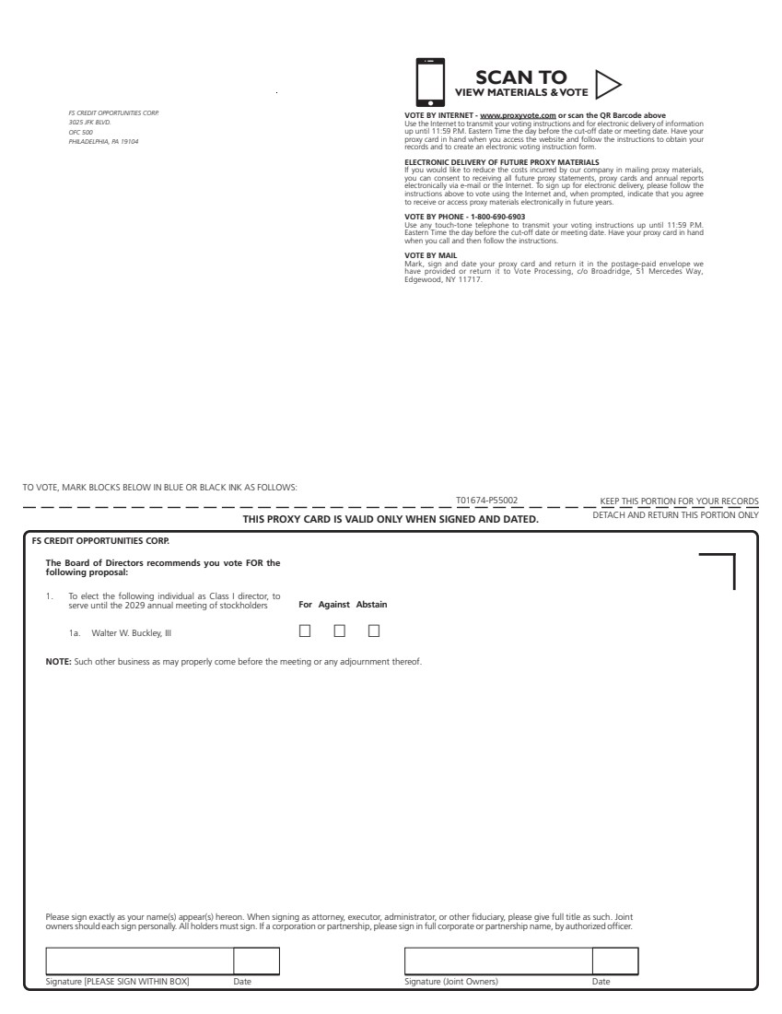 | Signature [PLEASE SIGN WITHIN BOX] Date Signature (Joint Owners) Date TO VOTE, MARK BLOCKS BELOW IN BLUE OR BLACK INK AS FOLLOWS: KEEP THIS PORTION FOR YOUR RECORDS DETACH AND RETURN THIS PORTION ONLY THIS PROXY CARD IS VALID ONLY WHEN SIGNED AND DATED. T01674-P55002 For Against Abstain ! ! ! NOTE: Such other business as may properly come before the meeting or any adjournment thereof. 1. To elect the following individual as Class I director, to serve until the 2029 annual meeting of stockholders FS CREDIT OPPORTUNITIES CORP. The Board of Directors recommends you vote FOR the following proposal: 1a. Walter W. Buckley, III Please sign exactly as your name(s) appear(s) hereon. When signing as attorney, executor, administrator, or other fiduciary, please give full title as such. Joint owners should each sign personally. All holders must sign. If a corporation or partnership, please sign in full corporate or partnership name, by authorized officer. SCAN TO VIEW MATERIALS & VOTEw FS CREDIT OPPORTUNITIES CORP. 3025 JFK BLVD. OFC 500 PHILADELPHIA, PA 19104 VOTE BY INTERNET - www.proxyvote.com or scan the QR Barcode above Use the Internet to transmit your voting instructions and for electronic delivery of information up until 11:59 P.M. Eastern Time the day before the cut-off date or meeting date. Have your proxy card in hand when you access the website and follow the instructions to obtain your records and to create an electronic voting instruction form. ELECTRONIC DELIVERY OF FUTURE PROXY MATERIALS If you would like to reduce the costs incurred by our company in mailing proxy materials, you can consent to receiving all future proxy statements, proxy cards and annual reports electronically via e-mail or the Internet. To sign up for electronic delivery, please follow the instructions above to vote using the Internet and, when prompted, indicate that you agree to receive or access proxy materials electronically in future years. VOTE BY PHONE - 1-800-690-6903 Use any touch-tone telephone to transmit your voting instructions up until 11:59 P.M. Eastern Time the day before the cut-off date or meeting date. Have your proxy card in hand when you call and then follow the instructions. VOTE BY MAIL Mark, sign and date your proxy card and return it in the postage-paid envelope we have provided or return it to Vote Processing, c/o Broadridge, 51 Mercedes Way, Edgewood, NY 11717.
 | 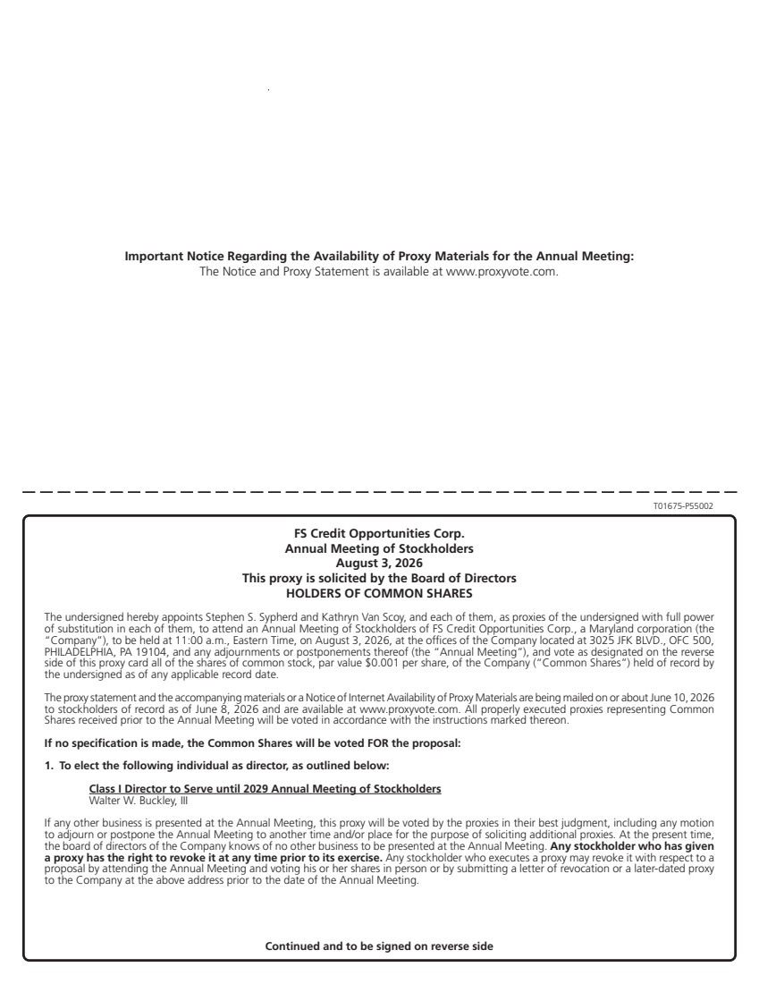 | T01675-P55002 FS Credit Opportunities Corp. Annual Meeting of Stockholders August 3, 2026 This proxy is solicited by the Board of Directors HOLDERS OF COMMON SHARES The undersigned hereby appoints Stephen S. Sypherd and Kathryn Van Scoy, and each of them, as proxies of the undersigned with full power of substitution in each of them, to attend an Annual Meeting of Stockholders of FS Credit Opportunities Corp., a Maryland corporation (the “Company”), to be held at 11:00 a.m., Eastern Time, on August 3, 2026, at the offices of the Company located at 3025 JFK BLVD., OFC 500, PHILADELPHIA, PA 19104, and any adjournments or postponements thereof (the “Annual Meeting”), and vote as designated on the reverse side of this proxy card all of the shares of common stock, par value $0.001 per share, of the Company (“Common Shares”) held of record by the undersigned as of any applicable record date. The proxy statement and the accompanying materials or a Notice of Internet Availability of Proxy Materials are being mailed on or about June 10, 2026 to stockholders of record as of June 8, 2026 and are available at www.proxyvote.com. All properly executed proxies representing Common Shares received prior to the Annual Meeting will be voted in accordance with the instructions marked thereon. If no specification is made, the Common Shares will be voted FOR the proposal: 1. To elect the following individual as director, as outlined below: Class I Director to Serve until 2029 Annual Meeting of Stockholders Walter W. Buckley, III If any other business is presented at the Annual Meeting, this proxy will be voted by the proxies in their best judgment, including any motion to adjourn or postpone the Annual Meeting to another time and/or place for the purpose of soliciting additional proxies. At the present time, the board of directors of the Company knows of no other business to be presented at the Annual Meeting. Any stockholder who has given a proxy has the right to revoke it at any time prior to its exercise. Any stockholder who executes a proxy may revoke it with respect to a proposal by attending the Annual Meeting and voting his or her shares in person or by submitting a letter of revocation or a later-dated proxy to the Company at the above address prior to the date of the Annual Meeting. Continued and to be signed on reverse side Important Notice Regarding the Availability of Proxy Materials for the Annual Meeting: The Notice and Proxy Statement is available at www.proxyvote.com.
 | 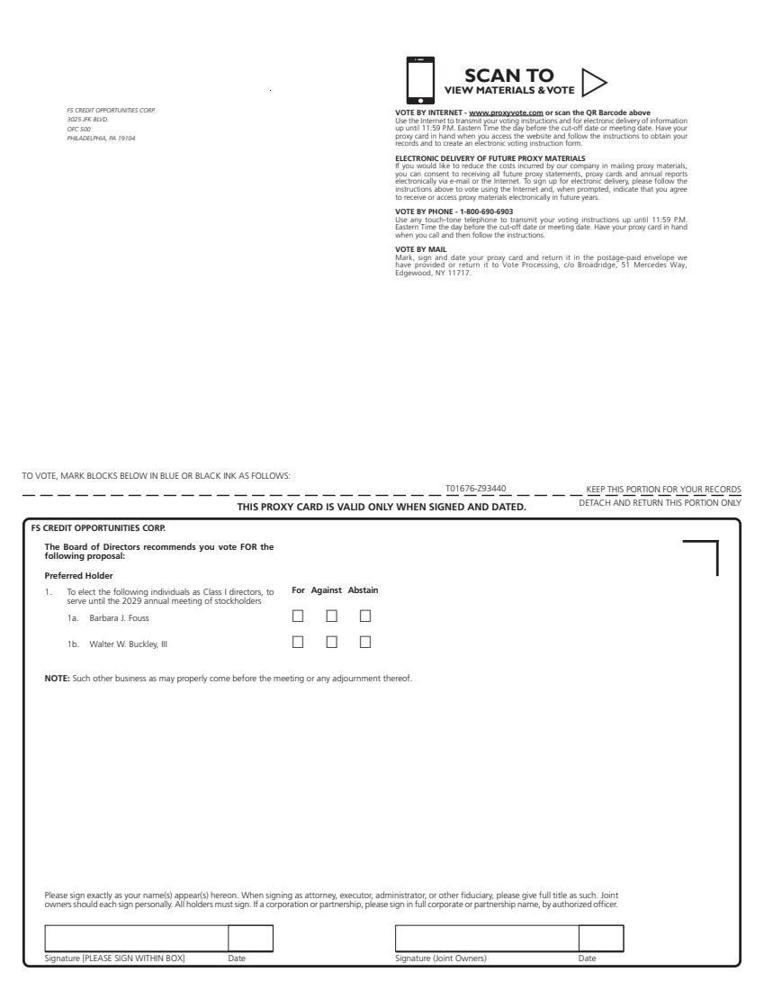 | Signature [PLEASE SIGN WITHIN BOX] Date Signature (Joint Owners) Date TO VOTE, MARK BLOCKS BELOW IN BLUE OR BLACK INK AS FOLLOWS: KEEP THIS PORTION FOR YOUR RECORDS DETACH AND RETURN THIS PORTION ONLY THIS PROXY CARD IS VALID ONLY WHEN SIGNED AND DATED. T01676-Z93440 For Against Abstain ! ! ! ! ! ! NOTE: Such other business as may properly come before the meeting or any adjournment thereof. 1. To elect the following individuals as Class I directors, to serve until the 2029 annual meeting of stockholders FS CREDIT OPPORTUNITIES CORP. The Board of Directors recommends you vote FOR the following proposal: Preferred Holder 1a. Barbara J. Fouss 1b. Walter W. Buckley, III Please sign exactly as your name(s) appear(s) hereon. When signing as attorney, executor, administrator, or other fiduciary, please give full title as such. Joint owners should each sign personally. All holders must sign. If a corporation or partnership, please sign in full corporate or partnership name, by authorized officer. SCAN TO VIEW MATERIALS & VOTEw FS CREDIT OPPORTUNITIES CORP. 3025 JFK BLVD. OFC 500 PHILADELPHIA, PA 19104 VOTE BY INTERNET - www.proxyvote.com or scan the QR Barcode above Use the Internet to transmit your voting instructions and for electronic delivery of information up until 11:59 P.M. Eastern Time the day before the cut-off date or meeting date. Have your proxy card in hand when you access the website and follow the instructions to obtain your records and to create an electronic voting instruction form. ELECTRONIC DELIVERY OF FUTURE PROXY MATERIALS If you would like to reduce the costs incurred by our company in mailing proxy materials, you can consent to receiving all future proxy statements, proxy cards and annual reports electronically via e-mail or the Internet. To sign up for electronic delivery, please follow the instructions above to vote using the Internet and, when prompted, indicate that you agree to receive or access proxy materials electronically in future years. VOTE BY PHONE - 1-800-690-6903 Use any touch-tone telephone to transmit your voting instructions up until 11:59 P.M. Eastern Time the day before the cut-off date or meeting date. Have your proxy card in hand when you call and then follow the instructions. VOTE BY MAIL Mark, sign and date your proxy card and return it in the postage-paid envelope we have provided or return it to Vote Processing, c/o Broadridge, 51 Mercedes Way, Edgewood, NY 11717.
 | 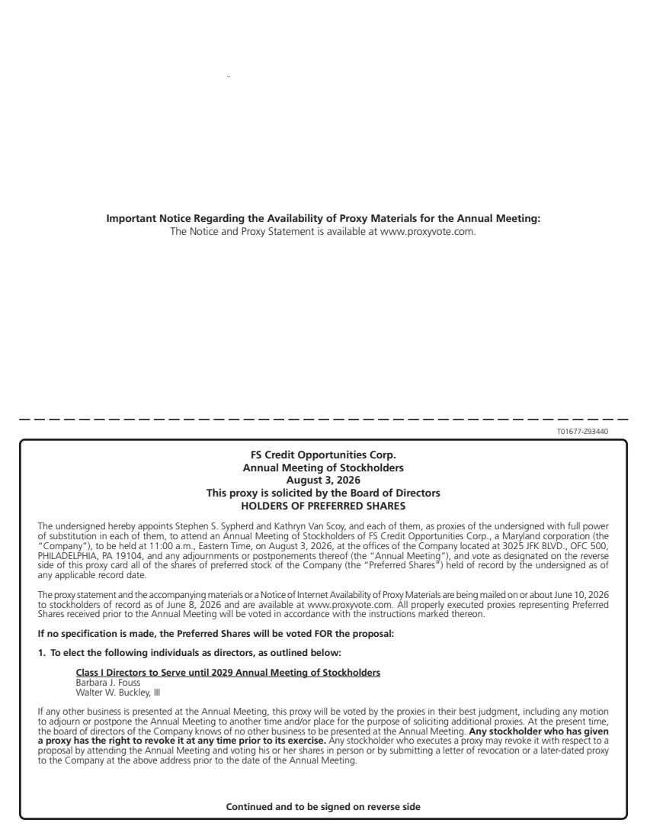 | T01677-Z93440 FS Credit Opportunities Corp. Annual Meeting of Stockholders August 3, 2026 This proxy is solicited by the Board of Directors HOLDERS OF PREFERRED SHARES The undersigned hereby appoints Stephen S. Sypherd and Kathryn Van Scoy, and each of them, as proxies of the undersigned with full power of substitution in each of them, to attend an Annual Meeting of Stockholders of FS Credit Opportunities Corp., a Maryland corporation (the “Company”), to be held at 11:00 a.m., Eastern Time, on August 3, 2026, at the offices of the Company located at 3025 JFK BLVD., OFC 500, PHILADELPHIA, PA 19104, and any adjournments or postponements thereof (the “Annual Meeting”), and vote as designated on the reverse side of this proxy card all of the shares of preferred stock of the Company (the “Preferred Shares”) held of record by the undersigned as of any applicable record date. The proxy statement and the accompanying materials or a Notice of Internet Availability of Proxy Materials are being mailed on or about June 10, 2026 to stockholders of record as of June 8, 2026 and are available at www.proxyvote.com. All properly executed proxies representing Preferred Shares received prior to the Annual Meeting will be voted in accordance with the instructions marked thereon. If no specification is made, the Preferred Shares will be voted FOR the proposal: 1. To elect the following individuals as directors, as outlined below: Class I Directors to Serve until 2029 Annual Meeting of Stockholders Barbara J. Fouss Walter W. Buckley, III If any other business is presented at the Annual Meeting, this proxy will be voted by the proxies in their best judgment, including any motion to adjourn or postpone the Annual Meeting to another time and/or place for the purpose of soliciting additional proxies. At the present time, the board of directors of the Company knows of no other business to be presented at the Annual Meeting. Any stockholder who has given a proxy has the right to revoke it at any time prior to its exercise. Any stockholder who executes a proxy may revoke it with respect to a proposal by attending the Annual Meeting and voting his or her shares in person or by submitting a letter of revocation or a later-dated proxy to the Company at the above address prior to the date of the Annual Meeting. Continued and to be signed on reverse side Important Notice Regarding the Availability of Proxy Materials for the Annual Meeting: The Notice and Proxy Statement is available at www.proxyvote.com.

