UNITED STATES
SECURITIES AND EXCHANGE COMMISSION
Washington, D.C. 20549

SCHEDULE 14A
(Rule 14a-101)

INFORMATION REQUIRED IN PROXY STATEMENT

SCHEDULE 14A INFORMATION

Proxy Statement Pursuant to Section 14(a) of
the Securities Exchange Act of 1934

Filed by the Registrant ☒

Filed by a Party other than the Registrant ☐

Check the appropriate box:

☐ | Preliminary Proxy Statement
☐ | Confidential, for Use of the Commission Only (as permitted by Rule 14a-6(e)(2))
☐ | Definitive Proxy Statement
☒ | Definitive Additional Materials
☐ | Soliciting Material under §240.14a-12

FS Credit Opportunities Corp.
(Name of Registrant as Specified in its Charter)

(Name of Person(s) Filing Proxy Statement, if other than the Registrant)

Payment of Filing Fee (Check the appropriate box):

☒ | No fee required.
☐ | Fee paid previously with preliminary materials.
☐ | Fee computed on table in exhibit required by Item 25(b) per Exchange Act Rules 14a-6(i)(1) and 0-11.

 | FS CREDIT OPPORTUNITIES CORP.

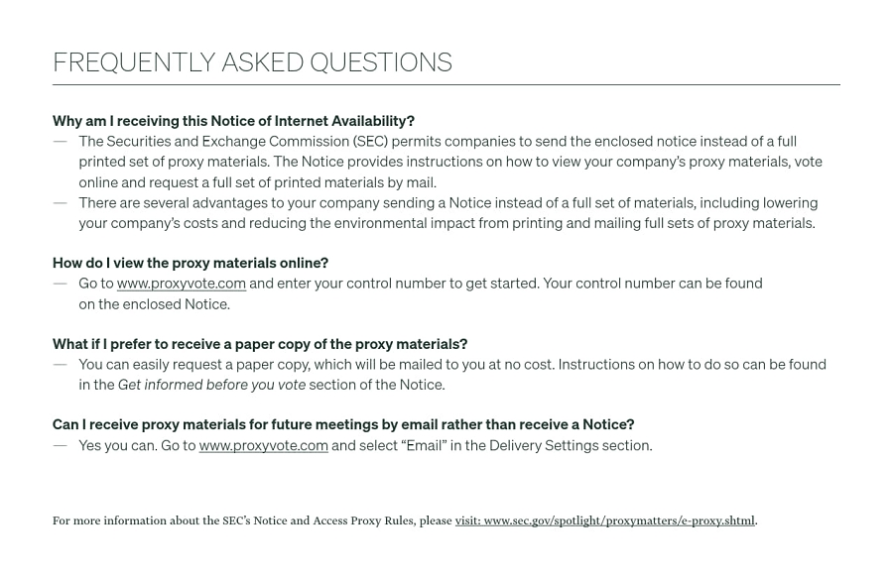 | Why am I receiving this Notice of Internet Availability? — The Securities and Exchange Commission (SEC) permits companies to send the enclosed notice instead of a full printed set of proxy materials. The Notice provides instructions on how to view your company’s proxy materials, vote online and request a full set of printed materials by mail. — There are several advantages to your company sending a Notice instead of a full set of materials, including lowering your company’s costs and reducing the environmental impact from printing and mailing full sets of proxy materials. How do I view the proxy materials online? — Go to www.proxyvote.com and enter your control number to get started. Your control number can be found on the enclosed Notice. What if I prefer to receive a paper copy of the proxy materials? — You can easily request a paper copy, which will be mailed to you at no cost. Instructions on how to do so can be found in the Get informed before you vote section of the Notice. Can I receive proxy materials for future meetings by email rather than receive a Notice? — Yes you can. Go to www.proxyvote.com and select “Email” in the Delivery Settings section. FREQUENTLY ASKED QUESTIONS For more information about the SEC’s Notice and Access Proxy Rules, please visit: www.sec.gov/spotlight/proxymatters/e-proxy.shtml.

